
Box PMB-J 130 Gardener's Circle Johns Island, SC 29455

Member Meeting 04/02/2025 @Seabrook Island Club

Thad Peterson, President, called the meeting to order at 6:22PM and opened with prayer.

Ray Hoover brought attention to the newly produced ECKS brochures and reiterated some stats from the Exchange Club showing that we are a large chapter of over 100 members and going strong!

Chris Stephenson honored South Carolina fallen hero, Specialist Javion S Sullivan and led members in the Pledge of Allegiance. See Bio attached

Thad welcomed and recognized guests. See attached attendance list.
Thad recognized and inducted new members:
Milum Livesay
Allan Stein
Timothy Barnard

Jack Wilson announced the winner to be recognized at the Angel Oaks Awards Banquet. There were 14 excellent nominations. The committee ultimately selected Kelly Carol from The Point. She was nominated by Phyllis Barber. Angel Oak Awards Banquet will be held at Wingate Place on May 21, 2025.

Bob Schick asked members to buy tickets and make donations to the Angel Oak fundraiser. Please consider sponsoring a table as this is a major fundraiser for the club. $1200 per table. Possibly consider your RMD’s as a good charitable strategy.

After dinner (7:20 PM) The featured speaker was introduced: D Jermaine Husser, Executive Director. Our Lady of Mercy Community Outreach See Bio attached

Meeting Adjourned at 7:55 PM
Next Meeting:
April 16, 2025 @Seabrook Island Club
Speaker: Education Grant Awards

Addendums:
Attendance
Fallen Hero
Speaker Bio

Minutes submitted 04/15/2025 by Sally Smith Nicoli, Club Secretary

Meeting Attendance
Member | Y/N | #
Victor Agusta | Y | 2
Michelle
Almeyda-Wiedemuth
Todd Anderson | N | 0
Alan Armstrong | Y | 1
Bill Bane | Y | 1
Phyllis Barber | Y | 1
Tim Barnard | Y | 1
Joe Bauer | Y | 1
Tom Berghausen | N | 0
Dave Berry | N | 0
Wayne Billian | n | 0
Renee Black | Y | 1
Herb Boehm | Y | 1
Rich Boss | N | 0
Lon Bouknight | Y | 1
Kevin Boyle | Y | 1
Ed Brett | Y | 1
Cathy Cleary | n | 0
Wes Cleary | N | 0
David Cruse | Y | 1
Bob Davis | N | 0
Gerrianne Delaney | N | 0
Fred Demler | Y | 1
Ambrose Ditloff
Art Dougherty | Y | 1
Bob Driscoll | Y | 1
Jim Dwyer | N | 0
Bruce Edwards | Y | 1
Frank Farfone* | Y | 1
George Fink | N | 0
Dick Fleming | Y | 1
Ted Flerlage | N | 0
Dianna Forsythe | N | 0
Joe Foti | N | 0
Dennis Giannos | Y | 1
Bill Good | Y | 1
Laurel Greer | N | 0
Richard Gwyn | Y | 1
Stephen Haines | N | 0
Andy Hamilton | N | 0
Mary Hamrick | N | 0
Edward Heskamp | N | 0
Christopher Hix | Y | 1
Ray Hoover | Y | 1
Ed Hughes | N | 0
Bill Huff | N | 0
Maurice Isaac | Y | 1
Randy Jones | n | 0
Phyllis Kaupp-Seas | N | 0
Tom Kroll
Julie Stiles-Lanzone
Ed Leary | Y | 1
Scott Lee | N | 0
Bob Leggett | Y | 1
Milum Livesay | Y | 1
Lars Lueders | Y | 1
Bruce Ludwin | Y | 1
Stan MacDonald | N | 0
Alan Madison | Y | 1
Bob Mason | N | 0
Lisa McDonald | Y | 1
Rick McDonald | Y | 1
Joy Millar | N | 0
Jay Miller | Y | 1
Michael Morris | Y | 1
Bill Nelson | Y | 1
Sally Nicoli | Y | 1
Maureen Oberg | Y | 1
Marty Penkhus | Y | 1
Steve Penkhus | Y | 1
Thad Peterson | Y | 1
Dustin Plunkett | Y | 2
Joel Pondelik | Y | 1
Russ Preston | Y | 1
Robert Quagliato | Y | 1
Allen Reed | N | 0
George Reinhart | n | 0
John Reock | Y | 2
Charles Riehl | Y | 1
Ed Rigtrup | Y | 1
Shirley Salvo | N | 0
Nancy Schibler | N | 0
Bob Schick | Y | 2
Ron Schildge | Y | 1
Bob Schmidt
John Sellinger
Charlie Septer | N | 0
John Sesody | Y | 1
Robert Speziale | N | 0
Roger Steel | Y | 1
Ken Steen | N | 0
Alan Stein | Y | 1
Chris Stephenson | Y | 1
Marj Stephenson | Y | 1
Chris Strobel | N | 0
Joe Thompson | N | 0
Dick Trent | Y | 1
Stan Ullner | N | 0
Bruce Van Voorhis | Y | 1
Dave Vetta | N | 0
Tom Webster | Y | 2
Pat Welch | Y | 1
Jack Wilson | Y | 1
Bill Wick | Y | 2
David Woodman | Y | 1
John Woychick | Y | 1
Mela Wyeth | Y | 1

Fallen Hero Presentation
Good evening, fellow Exchange Club members and guests,
Tonight, we pay tribute to Specialist Javion Shavonte Sullivan.
Javion Sullivan graduated from Fort Mill High School in 2011, where he stood out as a talented athlete and wrestler. His coach, Chris Brock, described him as “intimidating but humble” and “a gentle giant.” In just one season, he became a leader on the wrestling team, treating teammates and coaches with dignity while bringing a spirit of service to the team.
Javion met his wife, Raven, during junior high school at Cleveland Park. She was playing volleyball, and he was playing basketball. After several attempts to connect, she finally said yes. The two continued to date and married in 2015, later welcoming their daughter, Mahogany.
Driven by a desire to create a better life for his family and serve his country, Javion joined the Army in November 2015. His mother, Cynthia Sullivan, shared that Javion had always aspired to be a soldier, seeking challenges that were both physically and emotionally demanding. Despite her pleas for him to reconsider, Javion was resolute in his decision to serve his family, community, and country.
Specialist Sullivan was assigned to the 16th Signal Company, 11th Theater Tactical Signal Brigade, at Fort Hood, Texas. In 2016, he was deployed to Kuwait, and later to Iraq. On Sunday, January 7, 2018, Javion had been in a group text with family members who were shocked to hear of his passing the next day. According to the U.S. Department of Defense, Specialist Sullivan tragically died in a non-combat-related accident in Al Anbar Province, Iraq, just days before his 25th birthday.
His military awards and decorations include the Army Commendation Medal, National Defense Service Medal, Inherent Resolve Campaign Medal, Global War on Terrorism Service Medal, Army Service Ribbon, and Overseas Ribbon.
As an indication of our respect for Specialist Javion Shavonte Sullivan and others who gave their lives for our country, this *Exchange Club places U.S. flags around our community several times a year. Each flag bears a yellow ribbon with the name of a South Carolina fallen hero.
Specialist Javion Shavonte Sullivan, we salute you and your sacrifice on our behalf.
Please stand as you are able and join me in reciting the Pledge of Allegiance.

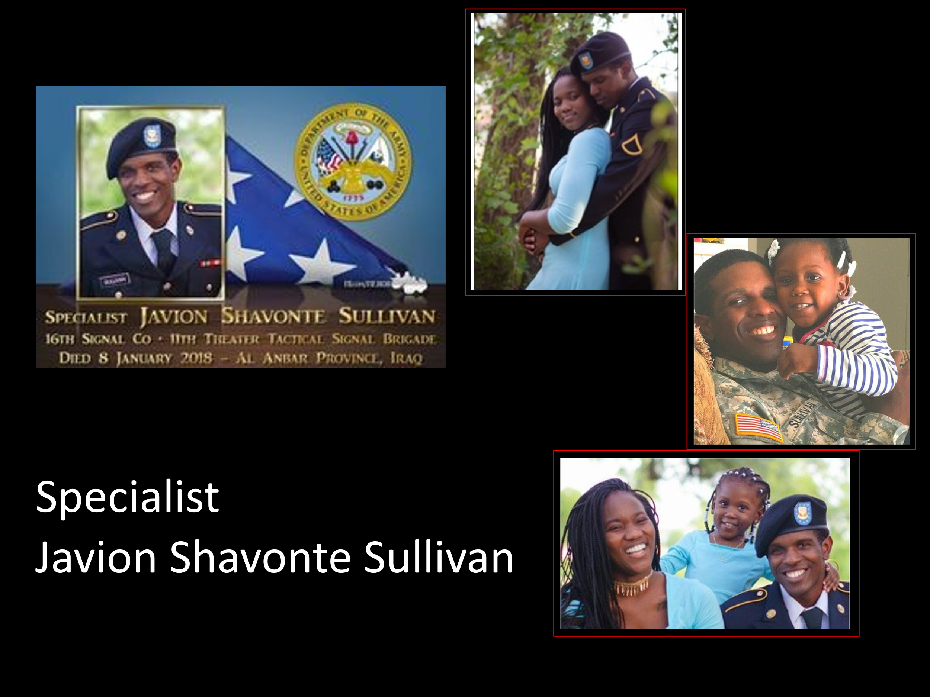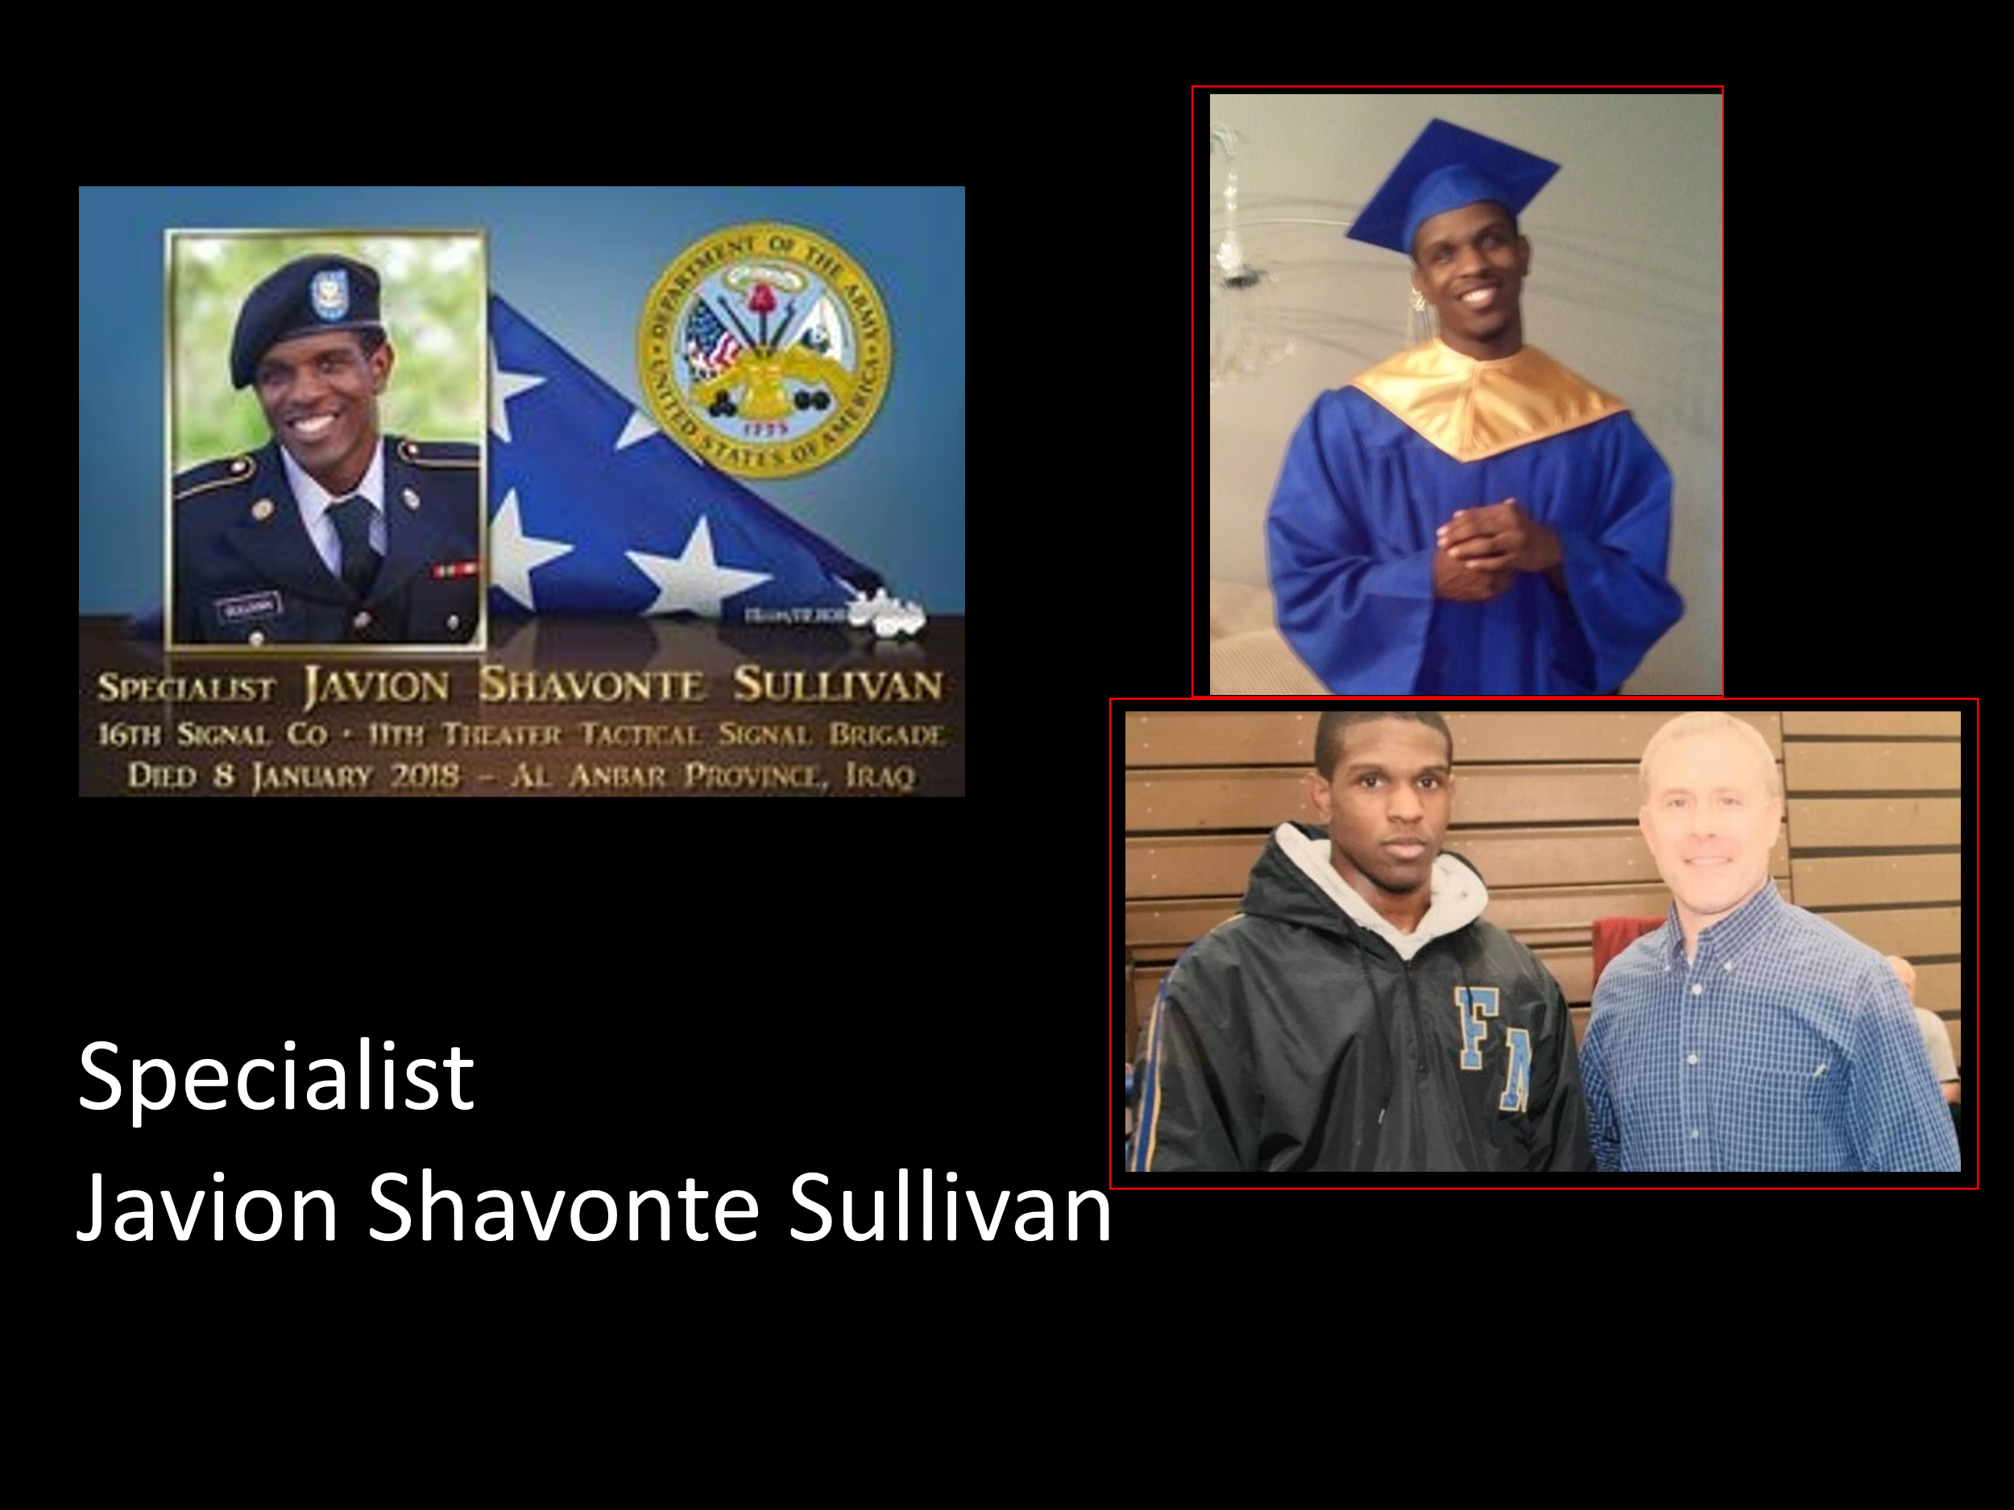

Featured Speaker Bio and Presentation
D. JERMAINE HUSSER

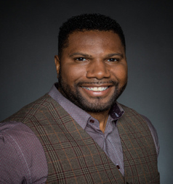
Biography
D. Jermaine Husser is currently the owner of JMaxwell Consulting which focuses on values-driven strategic planning, emerging leadership coaching, and philanthropy consulting. Prior to starting his own consulting firm, he was VP of Mission Enterprise for Palmetto Goodwill and Executive Director of Palmetto Warrior Connection (PWC), which is a community integration project to assist returning veterans/warriors and their families transition back into community.

Before Goodwill he served as the State Director of Students First SC in Columbia, SC, where he developed a five-year state plan, created outreach plans for members, parents, teachers, and elected officials, and lobbied for progressive education reform at the State House.

Prior to joining Students First SC, he was the Chief Executive Officer (CEO) of the Greater Pittsburgh Community Food Bank, based in Duquesne, PA. Before leading the Pittsburgh Food Bank, he was Executive Director of Lowcountry Food Bank, in Charleston, SC, a position he held since 2005.

Jermaine is an active participant in his community and has served on numerous professional and community organizations, such as co-chair of United Way’s African American Leadership Council, vice chair of the South Carolina Food Bank Association and a member of the National Action Committee (NAC) of Feeding America, and the Board of Trustees of Trident Technical College Foundation. He was named to Liberty Fellowship “Class of 2015”. He was a past president and the first African American president of the Historic Rotary Club of Charleston. In 2004 he was named to the Charleston Regional Business Journal’s 40 Under Forty.

Jermaine is currently a TEDx Charleston speaker’s coach.

A graduate of Trident Technical College with an Associate in Business degree and additional coursework at Charleston Southern University in Organizational Management. He is also a graduate of the American Express Leadership Academy and Leadership Charleston.

Jermaine is a native of Goose Creek, SC. He is married to his life partner and best friend Kayra Husser. He is also the proud father of 21-year-old daughter, Ariana Rivera, 15-year-old daughter, London Jade and 8-year- old son, Jaxon Donovan. Jermaine enjoys coaching emerging leaders, golfing, playing basketball, road cycling, reading novels, writing poetry, and traveling. He is a veteran of the U.S. Army.

Jermaine’s life goal is to impact ONE Million lives before he dies through his commitment to service above self.

