

Box PMB-J 130 Gardener's Circle Johns Island, SC 29455

**Member Meeting 03/19/2025 @Seabrook Island Club**

Thad Peterson, President, called the meeting to order at 6:23PM and opened with prayer.

Chris Stephenson honored South Carolina fallen hero, Specialist Jason Reed Haven and led members in the Pledge of Allegiance. *See Bio attached*

Thad welcomed and recognized guests. *See attached attendance list*.

Thad recognized and inducted new member, Edward Hughes

After dinner (7:22PM) Sally Nicoli introduced the evening’s speaker, Corey Hollenbeck, Executive Director of Compass Harbor.

Meeting Adjourned at 8:00 PM

**Next Meeting:**

April 2, 2025 @Seabrook Island Club

Speaker:

**Addendums:**

Attendance

Fallen Hero

Speaker Bio

**Minutes submitted 03/20/2025 by Sally Smith Nicoli, Club Secretary**

Dinner Attendance 03/19/2025

| Attended? | Member | Attended? | Guests | $s |
| --- | --- | --- | --- | --- |
| Yes | Alan Armstrong |  |  |  |
| Yes | Bill Bane |  |  |  |
| Yes | Phyllis Barber |  |  |  |
| No | Renee Black |  |  |  |
| Yes | Herb Boehm |  |  |  |
| Yes | Ed Brett |  |  |  |
| Yes | David Cruse |  |  |  |
| No | Ambrose Ditloff |  |  |  |
| Yes | Art Dougherty |  |  |  |
| No | Jim Dwyer |  |  |  |
| Yes | Bruce Edwards |  |  |  |
| Yes | George Fink |  |  |  |
| Yes | Dianna Forsythe |  |  |  |
| Yes | Stephen Haines |  |  |  |
| Yes | Edward Heskamp |  |  |  |
| Yes | Ed Hughes |  |  |  |
| No | Bill Huff |  |  |  |
| No | Julie Stiles-Lanzone |  |  |  |
| Yes | Ed Leary |  |  |  |
| Yes | Scott Lee |  |  |  |
| Yes | Bob Leggett |  |  |  |
| No | Milum Livesay |  |  |  |
| Yes | Lars Lueders |  |  |  |
| Yes | Bruce Ludwin |  |  |  |
| Yes | Alan Madison |  |  |  |
| No | Lisa McDonald |  |  |  |
| Yes | Rick McDonald |  |  |  |
| Yes | Joy Millar |  |  |  |
| Yes | Jay Miller |  |  |  |
| Yes | Bill Nelson |  |  |  |
| Yes | Sally Nicoli | Yes  No | Corey Hollenbeck  Barb Hornig |  |
| Yes | Marty Penkhus |  |  |  |
| Yes | Steve Penkhus |  |  |  |
| Yes | Thad Peterson |  |  |  |
| Yes | Russ Preston |  |  |  |
| Yes | Robert Quagliato |  |  |  |
| Yes | Ed Rigtrup |  |  |  |
| Yes | Shirley Salvo |  |  |  |
| Yes | Ron Schildge |  |  |  |
| Yes | Ribin Stebbins |  |  |  |
| Yes | Roger Steel |  |  |  |
| Yes | Chris Stephenson |  |  |  |
| No | Marj Stephenson |  |  |  |
| Yes | Joe Thompson |  |  |  |
| No | Dick Trent |  |  |  |
| Yes | Bruce Van Voorhis |  |  |  |
| Yes | Pat Welch |  |  |  |
| Yes | Jack Wilson |  |  |  |
| Yes | David Woodman |  |  |  |
| Yes | John Woychick |  |  |  |
| Yes | Mela Wyeth |  |  |  |

51 + 2 = 53 Meeting Day List

Count 50-55

Attendance 42 Members and 1 Guest for a total of 43

Fallen Hero Presentation:

Good evening fellow Exchange Club members and guests.

Tonight, we're paying tribute to Specialist Jayson Reed Haven.

Specialist Haven overcame serious obstacles early in life, yet emerged as a kind, gentle, and compassionate young man. He was amazingly intelligent and always sought ways to help others and make people feel better. He lit up a room when he entered, and his goofy grin was infectious to everyone around him. Jayson's many friends and fellow service members looked to him as a brother.

Specialist Haven, from Aiken, South Carolina, joined the Army in January 2020 and was assigned to Bravo Company, 1st Battalion, 118th Infantry Regiment, 218th Maneuver Enhancement Brigade, South Carolina Army National Guard.

On May 25, 2023, Specialist Jayson Reed Haven, just 20 years old, died supporting Operation Spartan Shield when his military vehicle rolled over during training at Udairi Range in the northwestern desert of Kuwait, about 20 miles from the southern border of Iraq. He died a few days before Memorial Day, a month before his 21st birthday, 2 months from returning home from a year-long deployment in Kuwait, and 3 months from beginning classes at his dream school, the University of Michigan, after transferring from USC in Columbia.

The South Carolina Guard's leader, Maj. Gen. Van McCarty, also mourned Haven's loss, saying "there are no words that can fully capture the impact that losing a soldier can have. Soldiers and their families are the fabric that holds our organization together. There is nothing that I can say or offer to the family of Specialist Haven, but know that my thoughts and prayers and that of a great many South Carolinians are with you. You are not alone in grieving; we are with you."

An average of 9 soldiers are killed each year in similar accidents. Specialist Haven’s death along with a series of other ground vehicle rollover deaths led the Government Accountability Office to overhaul drivers training and institute other measures including retrofitting old rollover-prone Humvees with anti-lock brakes and electronic stability control features that reduce the risk of such accidents.

As an indication of our respect for Specialist Jayson Reed Haven and others who gave their lives for our country, this Exchange Club places U.S. flags around our community several times a year. Each flag bears a yellow ribbon with the name of a South Carolina fallen hero.

Specialist Jayson Reed Haven, we salute you and your sacrifice on our behalf.

Please stand as you are able and join me in reciting the Pledge of Allegiance.

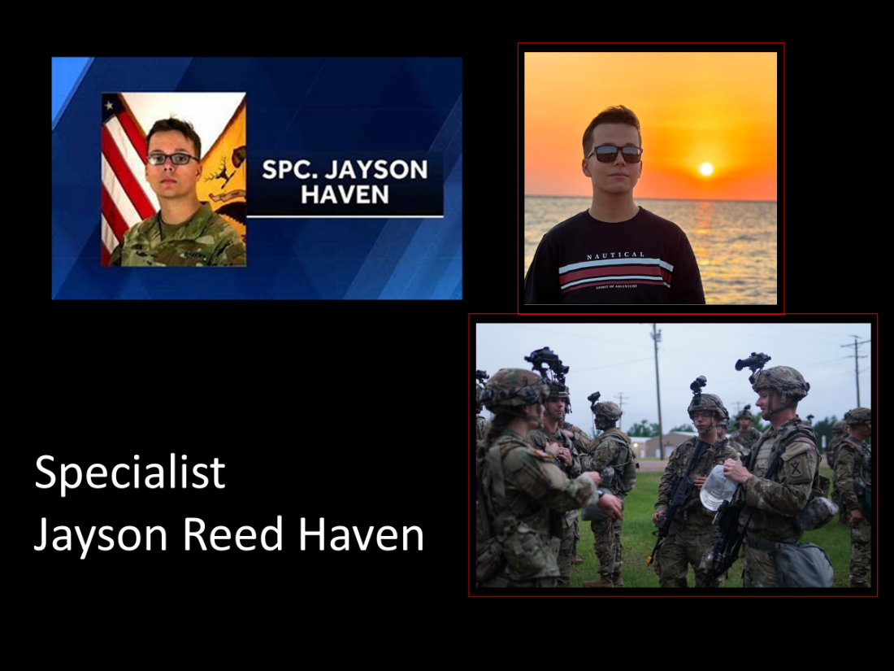

Featured Speaker



